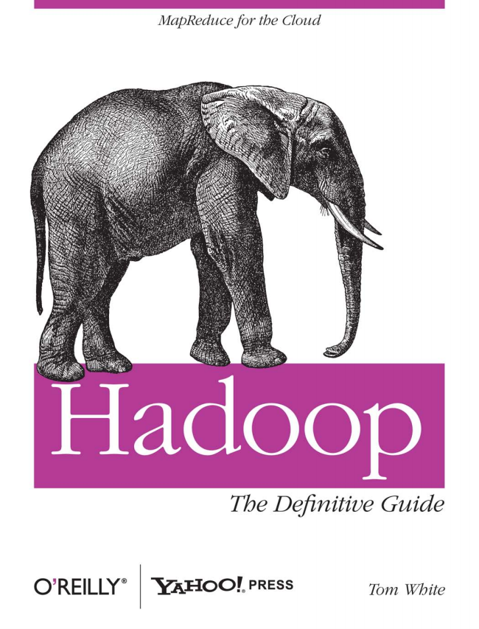

*S S MapReduce for the Cloud*

*The Definitive Guide*

O'REILLY” YAHOO! PRESS Tom White

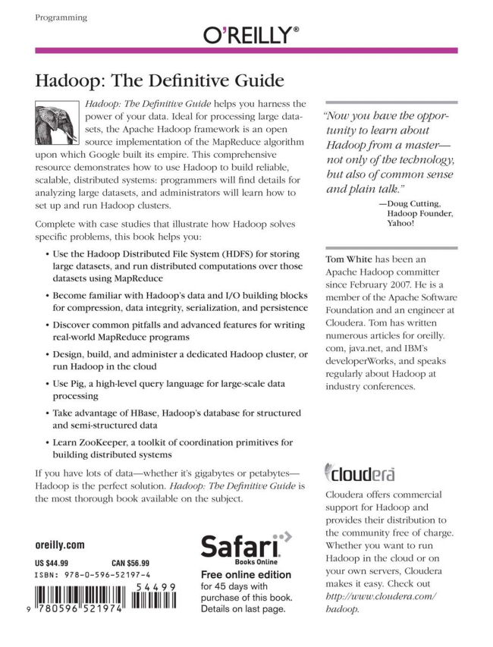

***9***

Programming

O’REILLY”

Hadoop: The Definitive Guide

Hadoop: The Definitive Guide helps you harness the power of your data. Ideal for processing large datasets, the Apache Hadoop framework is an open

- his source implementation of the MapReduce algorithm upon which Google built its empire. This comprehensive resource demonstrates how to use Hadoop to build reliable, scalable, distributed systems: programmers will find details for analyzing large datasets, and administrators will learn how to set up and run Hadoop clusters.

Complete with case studies that illustrate how Hadoop solves specific problems, this book helps you:

• Use the Hadoop Distributed File System (HDFS) for storing large datasets, and run distributed computations over those datasets using MapReduce

• Become familiar with Hadoop's data and I/O building blocks for compression, data integrity, serialization, and persistence

• Discover common pitfalls and advanced features for writing real-world MapReduce programs

• Design, build, and administer a dedicated Hadoop cluster, or run Hadoop in the cloud

• Use Pig, a high-level query language for large-scale data processing

• Take advantage of HBase, Hadoop's database for structured

and semi-structured data

• Learn ZooKeeper, a toolkit of coordination primitives for building distributed systems

If you have lots of data—whether it's gigabytes or petabytes Hadoop is the perfect solution. Hadoop: The Definitive Guide is the most thorough book available on the subject.

**Oreilly.com**

**US $44.99 CAN $56.99**

ISBN: 978-0-596–52 197 – A

5 4 4 9 9 |i

780596'52197

Safari’

**Books 0ոլine**

Free online edition for 45 days with purchase of this book. Details on last page.

*“Now you have the oppor*

*tunity to learn about Hadoop from a master not only of the technology, but also of common sense and plain talk.”*

—Doug Cutting,

Hadoop Founder, Yahoo!

Tom White has been an Apache Hadoop committer since February 2007. He is a member of the Apache Software Foundation and an engineer at Cloudera. Tom has written numerous articles for oreilly. com, java.net, and IBM's developerWorks, and speaks regularly about Hadoop at industry conferences.

"Clouderā

Cloudera offers commercial support for Hadoop and provides their distribution to the community free of charge. Whether you want to run Hadoop in the cloud or on your own servers, Cloudera makes it easy. Check out http://www.cloudera.com/ hadoop.

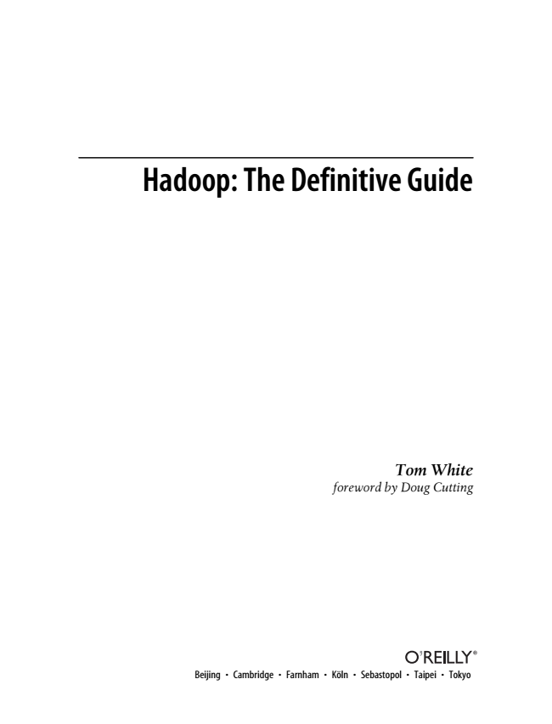

**Hadoop: The Definitive Guide**

*Tom White foreword by Doug Cutting*

Beijing • Cambridge • Farnham • Köln • Sebastopol • Taipei • Tokyo



**Hadoop: The Definitive Guide by Tom White**

Copyright © 2009 Tom White. All rights reserved. Printed in the United States of America.

Published by O’Reilly Media, Inc., 1005 Gravenstein Highway North, Sebastopol, CA 95472.

O’Reilly books may be purchased for educational, business, or sales promotional use. Online editions are also available for most titles (http://my.safaribooksonline.com). For more information, contact our corporate/institutional sales department: (800) 998-9938 or corporate@oreilly.com.

**Editor: Production Proofreader:**

Mike Editor: Loukides

Nancy Loranah Kotary

Dimant

**Indexer: Cover Interior Illustrator: Designer: Designer:**

Ellen Robert Troutman Karen David Romano

Montgomery

Futato Zaig

**Printing History:**

June 2009: First Edition.

Nutshell Handbook, the Nutshell Handbook logo, and the O’Reilly logo are registered trademarks of O’Reilly Media, Inc. Hadoop: The Definitive Guide, the image of an African elephant, and related trade dress are trademarks of O’Reilly Media, Inc.

Many of the designations used by manufacturers and sellers to distinguish their products are claimed as trademarks. Where those designations appear in this book, and O’Reilly Media, Inc. was aware of a trademark claim, the designations have been printed in caps or initial caps.

While every precaution has been taken in the preparation of this book, the publisher and author assume no responsibility for errors or omissions, or for damages resulting from the use of the information con- tained herein.

**TM**

This book uses RepKoverTM, a durable and flexible lay-flat binding.

ISBN: 978-0-596-52197-4

[M]

1243455573



*For Eliane, Emilia, and Lottie*

**

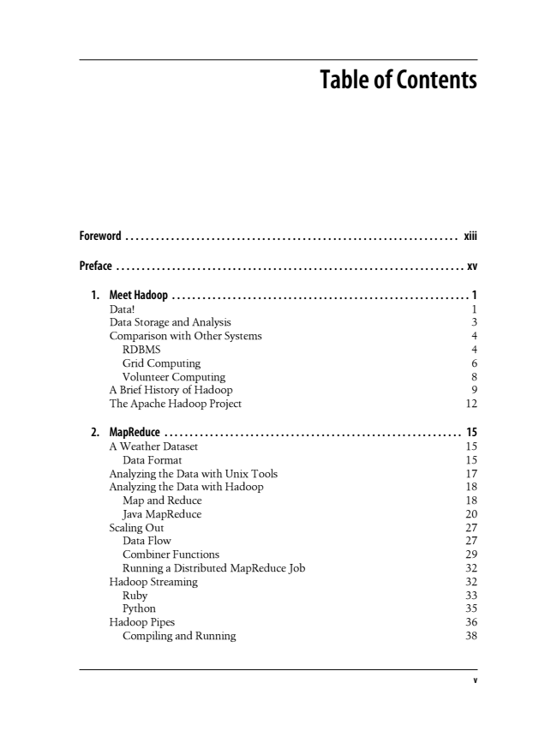

**Table of Contents**

**Foreword . . . . . . . . . . . . . . . . . . . . . . . . . . . . . . . . . . . . . . . . . . . . . . . . . . . . . . . . . . . . . . . . . . xiii**

**Preface . . . . . . . . . . . . . . . . . . . . . . . . . . . . . . . . . . . . . . . . . . . . . . . . . . . . . . . . . . . . . . . . . . . . . xv**

1. Meet Hadoop . . . . . . . . . . . . . . . . . . . . . . . . . . . . . . . . . . . . . . . . . . . . . . . . . . . . . . . . . . . 1 Data! 1 Data Storage and Analysis 3 Comparison with Other Systems 4 RDBMS 4 Grid Computing 6 Volunteer Computing 8 A Brief History of Hadoop 9 The Apache Hadoop Project 12

2. MapReduce ........................................................... 15 A Weather Dataset 15 Data Format 15 Analyzing the Data with Unix Tools 17 Analyzing the Data with Hadoop 18 Map and Reduce 18 Java MapReduce 20 Scaling Out 27 Data Flow 27 Combiner Functions 29 Running a Distributed MapReduce Job 32 Hadoop Streaming 32 Ruby 33 Python 35 Hadoop Pipes 36 Compiling and Running 38

**v**

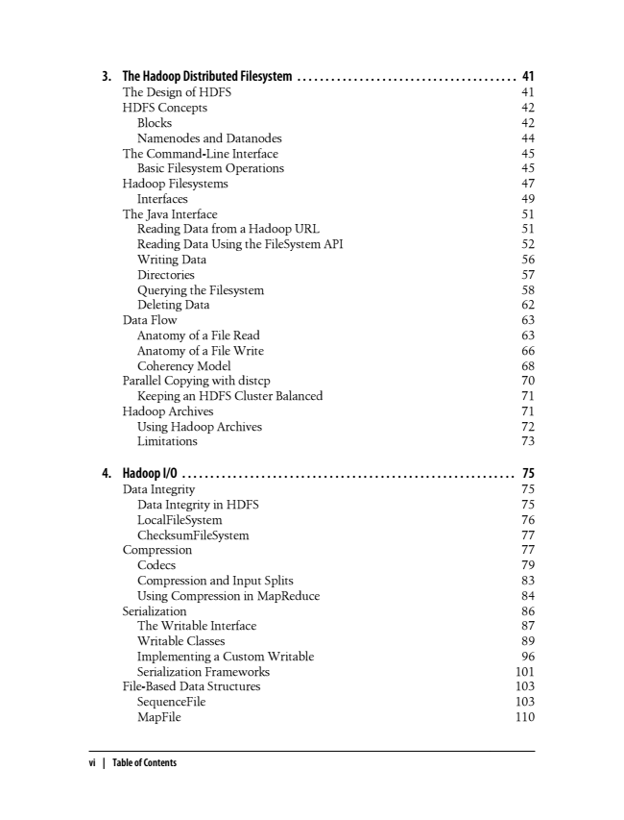

3. The Hadoop Distributed Filesystem . . . . . . . . . . . . . . . . . . . . . . . . . . . . . . . . . . . . . . . 41 The Design of HDFS 41 HDFS Concepts 42 Blocks 42 Namenodes and Datanodes 44 The Command-Line Interface 45 Basic Filesystem Operations 45 Hadoop Filesystems 47 Interfaces 49 The Java Interface 51 Reading Data from a Hadoop URL 51 Reading Data Using the FileSystem API 52 Writing Data 56 Directories 57 Querying the Filesystem 58 Deleting Data 62 Data Flow 63 Anatomy of a File Read 63 Anatomy of a File Write 66 Coherency Model 68 Parallel Copying with distcp 70 Keeping an HDFS Cluster Balanced 71 Hadoop Archives 71 Using Hadoop Archives 72 Limitations 73

4. Hadoop I/O ........................................................... 75 Data Integrity 75 Data Integrity in HDFS 75 LocalFileSystem 76 ChecksumFileSystem 77 Compression 77 Codecs 79 Compression and Input Splits 83 Using Compression in MapReduce 84 Serialization 86 The Writable Interface 87 Writable Classes 89 Implementing a Custom Writable 96 Serialization Frameworks 101 File-Based Data Structures 103 SequenceFile 103 MapFile 110

**vi | Table of Contents**

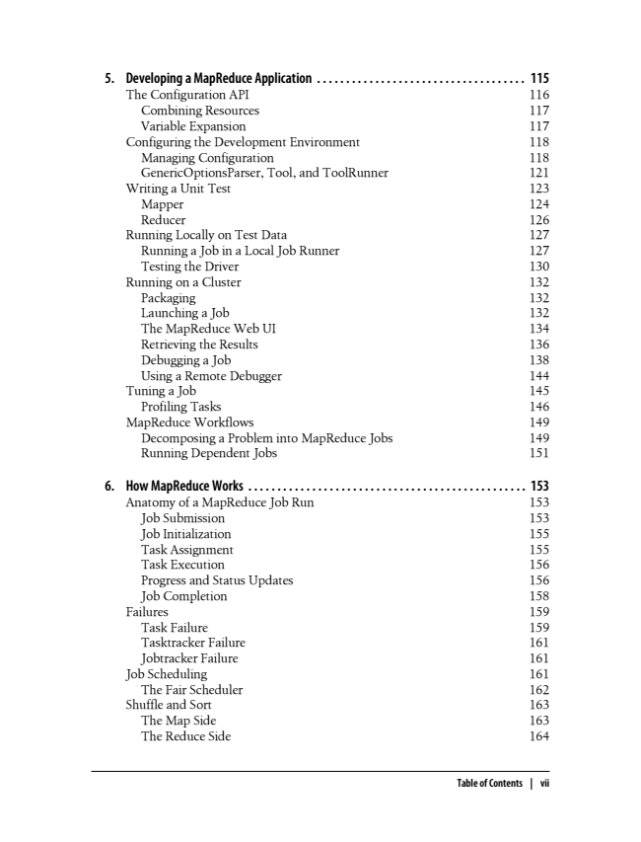

5. Developing a MapReduce Application . . . . . . . . . . . . . . . . . . . . . . . . . . . . . . . . . . . . 115 The Configuration API 116 Combining Resources 117 Variable Expansion 117 Configuring the Development Environment 118 Managing Configuration 118 GenericOptionsParser, Tool, and ToolRunner 121 Writing a Unit Test 123 Mapper 124 Reducer 126 Running Locally on Test Data 127 Running a Job in a Local Job Runner 127 Testing the Driver 130 Running on a Cluster 132 Packaging 132 Launching a Job 132 The MapReduce Web UI 134 Retrieving the Results 136 Debugging a Job 138 Using a Remote Debugger 144 Tuning a Job 145 Profiling Tasks 146 MapReduce Workflows 149 Decomposing a Problem into MapReduce Jobs 149 Running Dependent Jobs 151

6. How MapReduce Works . . . . . . . . . . . . . . . . . . . . . . . . . . . . . . . . . . . . . . . . . . . . . . . . 153 Anatomy of a MapReduce Job Run 153 Job Submission 153 Job Initialization 155 Task Assignment 155 Task Execution 156 Progress and Status Updates 156 Job Completion 158 Failures 159 Task Failure 159 Tasktracker Failure 161 Jobtracker Failure 161 Job Scheduling 161 The Fair Scheduler 162 Shuffle and Sort 163 The Map Side 163 The Reduce Side 164

**Table of Contents | vii**

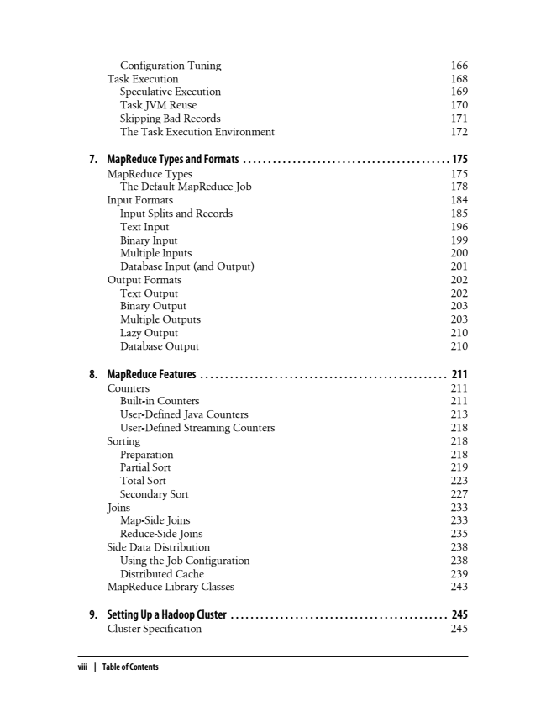

Configuration Tuning 166 Task Execution 168 Speculative Execution 169 Task JVM Reuse 170 Skipping Bad Records 171 The Task Execution Environment 172

7. MapReduce Types and Formats . . . . . . . . . . . . . . . . . . . . . . . . . . . . . . . . . . . . . . . . . . 175 MapReduce Types 175 The Default MapReduce Job 178 Input Formats 184 Input Splits and Records 185 Text Input 196 Binary Input 199 Multiple Inputs 200 Database Input (and Output) 201 Output Formats 202 Text Output 202 Binary Output 203 Multiple Outputs 203 Lazy Output 210 Database Output 210

8. MapReduce Features . . . . . . . . . . . . . . . . . . . . . . . . . . . . . . . . . . . . . . . . . . . . . . . . . . 211 Counters 211 Built-in Counters 211 User-Defined Java Counters 213 User-Defined Streaming Counters 218 Sorting 218 Preparation 218 Partial Sort 219 Total Sort 223 Secondary Sort 227 Joins 233 Map-Side Joins 233 Reduce-Side Joins 235 Side Data Distribution 238 Using the Job Configuration 238 Distributed Cache 239 MapReduce Library Classes 243

**9. Setting Up a Hadoop Cluster . . . . . . . . . . . . . . . . . . . . . . . . . . . . . . . . . . . . . . . . . . . . 245 Cluster Specification 245**

**viii | Table of Contents**